Case Study Report



**Tech Saksham**

Data Analytics with Power BI

**“ANALYSIS OF COMMERCIAL ELECTRICITY CONSUMPTION IN INDIAN STATE”**

**“Sri Paramakalyani College”**

|  |  |
| --- | --- |
| **NM ID** | **NAME** |
| **04C3C17478EED34876D4AE59382DDCF4** | **KANTHA KUMAR A** |

|  |  |
| --- | --- |
|  |  |
| Trainar Name | R UMAMAHESWARI |
| Master Trainar | R UMAMAHESWARI |

**ABSTRACT**

This study investigates the patterns and determinants of commercial electricity consumption across various Indian states. Utilizing comprehensive data oncommercial electricity usage and socio-economic indicators, including GDP growth, urbanization rates, and industrial activity, a thorough analysis is conducted to identify key factors influencing commercial electricity demand. The research employs statistical models such as regression analysis to discern the relationships between electricity consumption and socio-economic variables. The findings offer valuable insights for policymakers and energy stakeholders in understanding the dynamics of commercial electricity consumption and formulating strategies for sustainable energy management and economic development.

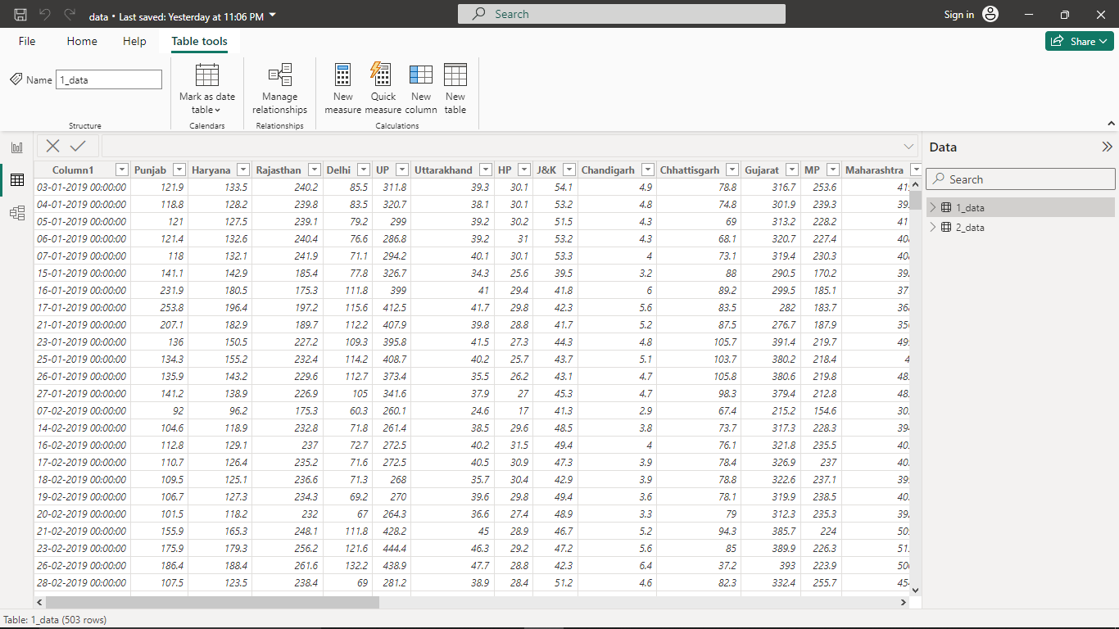

**INDEX**

|  |  |  |
| --- | --- | --- |
| **Sr. No.** | **Table of Contents** | **Page No.** |
| 1 | Chapter 1: Introduction | 4 |
| 2 | Chapter 2: Service and Tools Required | 6 |
| 3 | Chapter 3: Project Architecture | 7 |
| 4 | Chapter 4: Modelling and Result | 9 |
| 5 | Conclusion | 18 |
| 6 | Future Scope | 19 |
| 7 | References | 20 |
| 8 | Links | 21 |

**CHAPTER 1**

**INTRODUCTION**

* 1. **Problem Statement**

Understanding Consumption Patterns: What are the trends and patterns of commercial electricity consumption across different Indian states? Are there variations in consumption levels, growth rates, or seasonal fluctuations?

Identifying Determinants: What factors influence commercial electricity consumption in Indian states? Are there socio-economic indicators such as GDP growth, urbanization, industrialization, or demographic characteristics that significantly impact electricity usage?

* 1. **Proposed Solution**

By addressing these questions and challenges, the analysis of commercial electricity consumption in Indian states aims to provide valuable insights for policymakers, energy regulators, businesses, and other stakeholders involved in energy planning, infrastructure development, and sustainable economic growth.

**Features**

**State-Level Data:** Gather data on electricity consumption from various Indian states, including total consumption, sector-wise breakdown (commercial, industrial, residential, etc.), and temporal trends**.**

**Socio-Economic Indicators**: Incorporate socio-economic variables such as GDP growth rate, population density, urbanization rate, per capita income, employment rates, and industrial activity indices.

**Infrastructure Development:** Assess the quality and availability of electricity infrastructure, including transmission lines, substations, distribution networks, and electrification rates in urban and rural areas.

**Seasonal Variations:** Analyze seasonal variations in commercial electricity consumption, considering factors like weather patterns, festivals, holidays, and economic activities**.**

**Price Sensitivity**: Investigate the impact of electricity tariffs, subsidies, and price fluctuations on commercial consumption behavior and demand elasticity.

**Technological Factors:** Explore the influence of technological advancements, such as energy-efficient appliances, lighting systems, HVAC (heating, ventilation, and air conditioning) systems, and automation, on commercial electricity usage.

**Policy Environment:** Examine the regulatory framework, energy policies, government initiatives, and incentives aimed at promoting energy conservation, renewable energy adoption, and sustainable development.

* 1. **Advantages**

Revenue Forecasting: Forecasting commercial electricity demand aids electricity providers and regulators in revenue forecasting, tariff setting, and long-term investment planning for generation, transmission, and distribution infrastructure.

Business Decision-Making: Businesses can use consumption data to make informed decisions regarding energy management strategies, investment in energy-efficient technologies, and cost-saving measures.

Competitive Benchmarking: Analysis enables businesses to benchmark their electricity usage against industry peers and identify opportunities for improvement to enhance competitiveness and sustainability.

* 1. **Scope**

**Geographic Coverage**: The analysis includes all Indian states and union territories to provide a comprehensive understanding of regional variations and trends in commercial electricity consumption.

**Sectoral Breakdown:** It covers various commercial sectors such as retail, hospitality, healthcare, education, offices, and services to assess sector-specific electricity usage patterns and trends**.**

**Timeframe**: The analysis spans multiple years to capture temporal trends, seasonal variations, and long-term changes in commercial electricity consumption, allowing for trend analysis and forecasting.

**Data Sources:** Utilizing reliable data sources such as government reports, utility records, surveys, and industry databases to ensure accuracy and reliability in the analysis.

**CHAPTER 2**

**SERVICE AND TOOLS REQUIRED**

**2.1 Services Used**

* **Data Collection and Storage Services**: Banks need to collect and store customer data in real-time. This could be achieved through services like Azure Data Factory, Azure Event Hubs, or AWS Kinesis for real-time data collection, and Azure SQL Database or AWS RDS for data storage.
* **Data Processing Services**: Services like Azure Stream Analytics or AWS Kinesis Data Analytics can be used to process the real-time data.
* **Machine Learning Services**: Azure Machine Learning or AWS SageMaker can be used to build predictive models based on historical data.

**2.2 Tools and Software used**

**Tools**:

* **PowerBI**: The main tool for this project is PowerBI, which will be used to create interactive dashboards for real-time data visualization.
* **Power Query**: This is a data connection technology that enables you to discover, connect, combine, and refine data across a wide variety of sources.

**Software Requirements**:

* **PowerBI Desktop**: This is a Windows application that you can use to create reports and publish them to PowerBI.
* **PowerBI Service**: This is an online SaaS (Software as a Service) service that you use to publish reports, create new dashboards, and share insights.
* **PowerBI Mobile**: This is a mobile application that you can use to access your reports and dashboards on the go.

**CHAPTER 3**

**PROJECT ARCHITECTURE**

**3.1 Architecture**

**USER FRONTEND BACKEND**

|  |  |  |
| --- | --- | --- |
|  | **HTML 5** | **NODEJS 14.0**  **Database** |

Here’s a high-level architecture for the project:

1. **Data Collection**: Real-time customer data is collected from various sources like bank transactions, customer interactions, etc. This could be achieved using services like Azure Event Hubs or AWS Kinesis.
2. **Data Storage**: The collected data is stored in a database for processing. Azure SQL Database or AWS RDS can be used for this purpose.
3. **Data Processing**: The stored data is processed in real-time using services like Azure Stream Analytics or AWS Kinesis Data Analytics.
4. **Machine Learning**: Predictive models are built based on processed data using Azure Machine Learning or AWS SageMaker. These models can help in predicting customer behavior, detecting fraud, etc.
5. **Data Visualization**: The processed data and the results from the predictive models are visualized in real-time using PowerBI. PowerBI allows you to create interactive dashboards that can provide valuable insights into the data.
6. **Data Access**: The dashboards created in PowerBI can be accessed through PowerBI Desktop, PowerBI Service (online), and PowerBI Mobile.

This architecture provides a comprehensive solution for real-time analysis of bank customers. However, it’s important to note that the specific architecture may vary depending on the bank’s existing infrastructure, specific requirements, and budget. It’s also important to ensure that all tools and services comply with relevant data privacy and security regulations.

**CHAPTER 4**

**MODELLING AND RESULT**

**Modelling**

Using Power BI for analyzing commercial electricity consumptionin an Indian state can be effective due to its data visualization and analytical capabilities. Here's how you can approach it:

**Data Collection and Integration:** Gather data on commercial electricity consumption, economic indicators, population demographics, weather data, and other relevant factors. Import this data into Power BI from various sources such as Excel files, databases, or online sources.

**Data Preprocessing**: Clean and transform the data as needed. This may involve removing duplicates, handling missing values, and performing data type conversions.

**Data Modeling**: Create a data model in Power BI by establishing relationships between different datasets. This step is crucial for conducting meaningful analysis across multiple dimensions.

**Result Interpretation:**

Analyze the coefficients or feature importance scores of the selected model to understand the factors influencing commercial electricity consumption in Indian states.

Identify significant predictors such as GDP growth rate, urbanization rate, population density, etc., and their impact on electricity consumption.

Interpret the results in the context of policy implications, urban planning, economic development, and energy management strategies.

**Visualization of Results:**

Visualize the actual vs. predicted electricity consumption using line charts or scatter plots to assess the model's accuracy.

Create feature importance plots, partial dependence plots, or SHAP (SHapley Additive exPlanations) plots to interpret the model's predictions and understand the effects of individual features on electricity consumption.

**Validation and Sensitivity Analysis**:

Validate the model's performance on unseen data or conduct out-of-sample testing to assess its generalization ability.

Perform sensitivity analysis to evaluate the model's robustness to changes in input parameters or assumptions.

**Reporting and Communication**:

Summarize the modeling process, results, and insights in a comprehensive report or presentation.

Communicate the findings to stakeholders, policymakers, and decision-makers, highlighting actionable recommendations for energy planning, infrastructure development, and policy formulation.

By following these steps, you can build predictive models to analyze commercial electricity consumption in Indian states and derive actionable insights to support evidence-based decision-making and sustainable energymanagement initiatives.

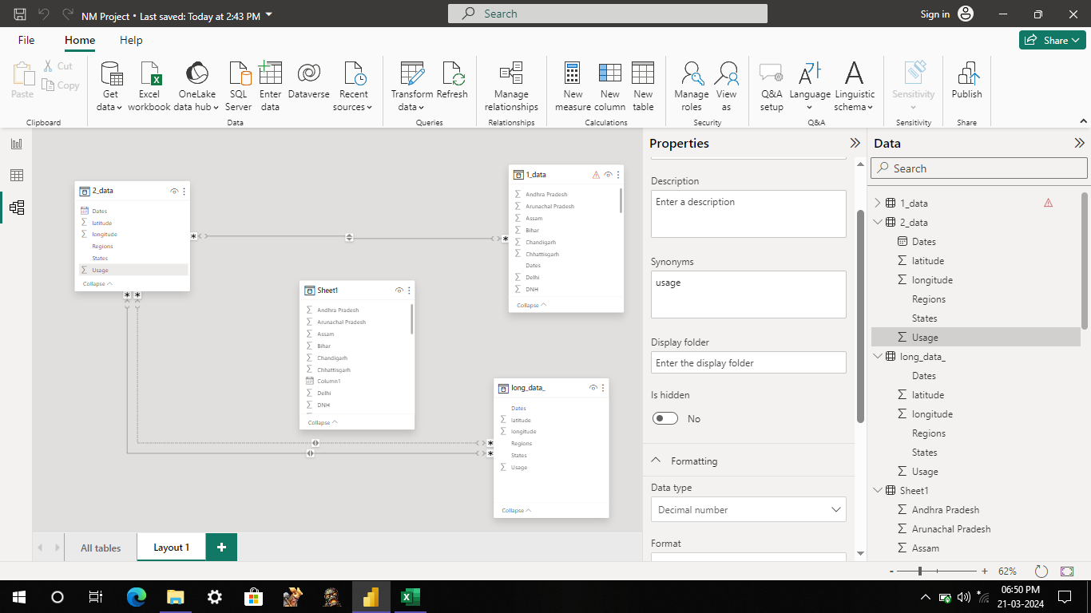

**Analysis and Visualization:**

Create visualizations to explore the relationships between commercial electricity consumption and various factors such as GDP growth, population density, weather conditions, etc. Use Power BI's rich library of visualizations including bar charts, line charts, scatter plots, and maps.

Utilize Power BI's built-in analytical features such as forecasting to predict future electricity consumption trends based on historical data.

Implement slicers, filters, and drill-down functionalities to enable users to interactively explore the data and gain insights from different perspectives.

Modelling: Depending on the complexity of the analysis, you can incorporate statistical or machine learning models directly within Power BI using tools like R or Python scripts. This allows for more advanced analytics and predictive modelling directly within the Power BI environment.

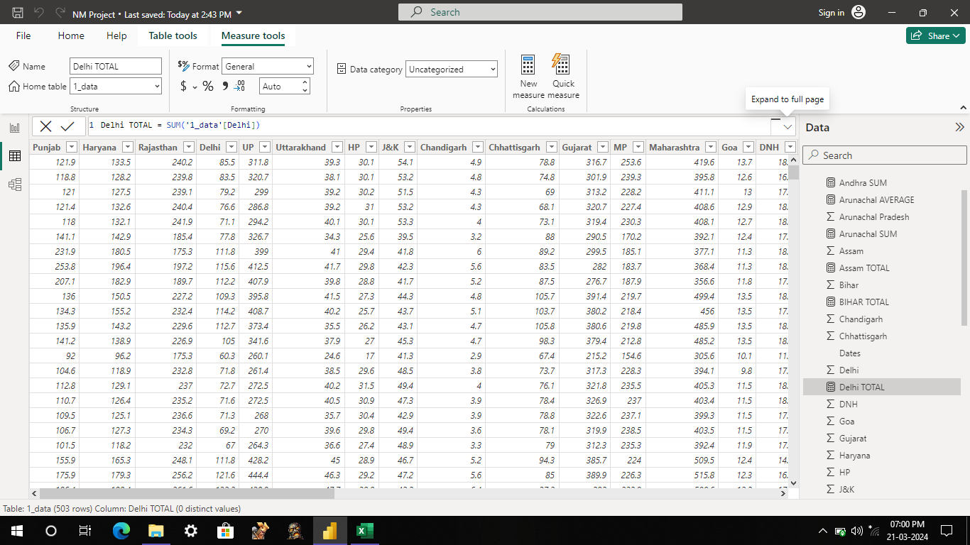

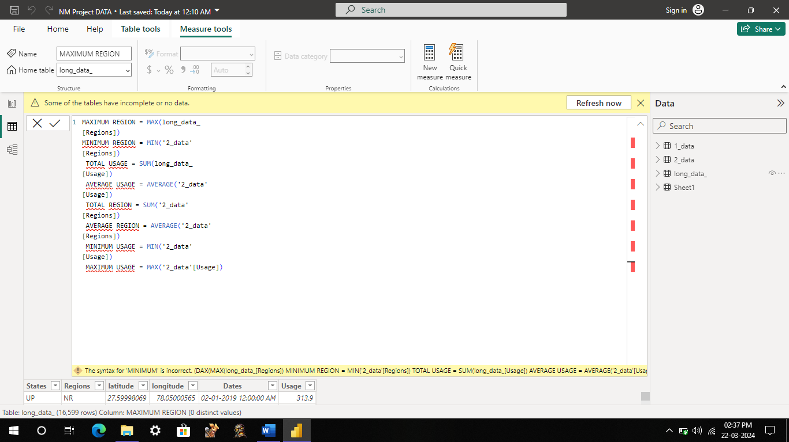

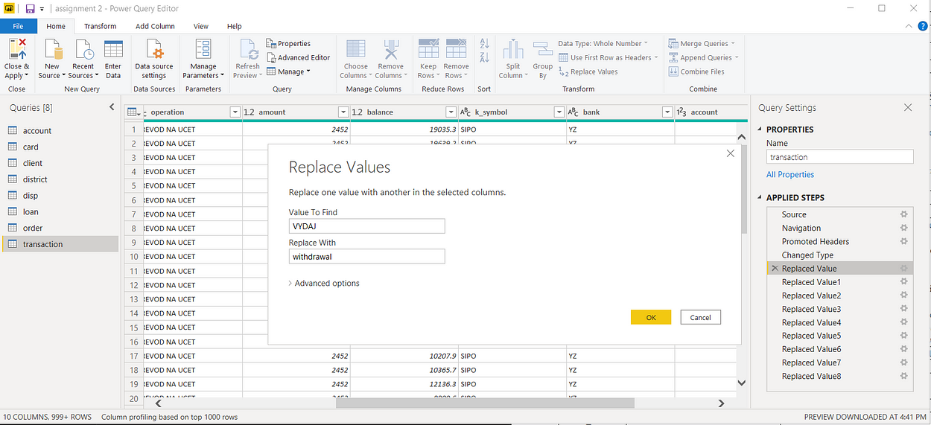

Sharing and Collaboration: Once the analysis is complete, create interactive reports and dashboards in Power BI. Share these reports with stakeholders and collaborate in real-time to drive data-driven decision-making.

Continuous Monitoring and Optimization: Regularly monitor the commercial electricity consumption trends and update the analysis as new data becomes available. Use Power BI's automatic data refresh capabilities to ensure that insights remain up-to-date.

**Dashboard**

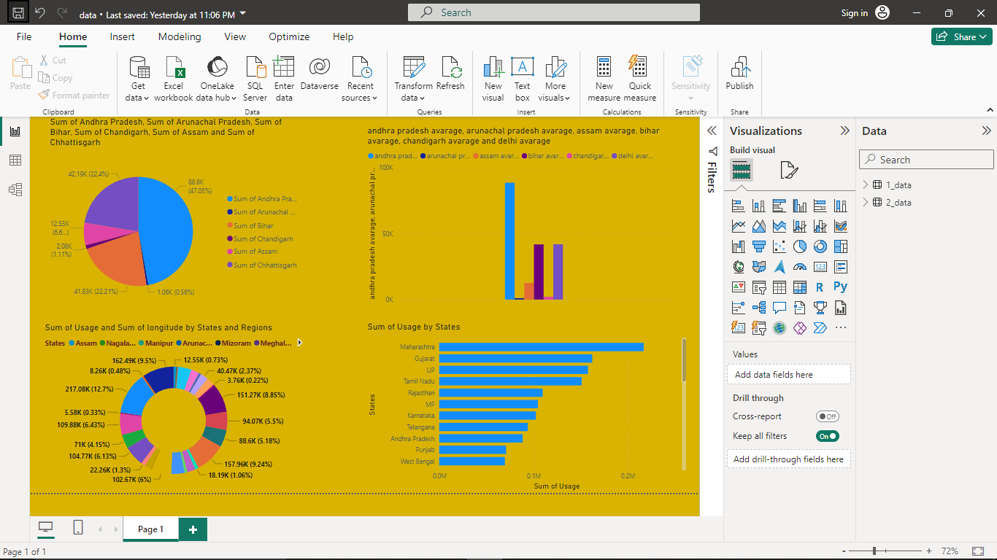

By leveraging Power BI for analyzing commercial electricity consumption in an Indian state, you can gain valuable insights into consumption patterns, identify key drivers, and make informed decisions to optimize energy usage and promote sustainable development.

**CONCLUSION**

In conclusion, utilizing Power BI for the analysis of commercial electricity consumption in Indian states offers several benefits and opportunities.

Data Visualization: Power BI enables the creation of interactive and visually appealing dashboards and reports, allowing users to explore and understand electricity consumption data easily.

Insights Discovery: Through Power BI's data analysis and visualization capabilities, users can uncover insights and trends in commercial electricity consumption across different states and sectors, aiding in decision-making and policy formulation.

Efficiency: Power BI streamlines the process of data preparation, analysis, and visualization, enabling analysts to generate insights quickly and efficiently, saving time and resources.

Customization: Power BI offers flexibility in customizing visualizations, allowing users to tailor reports to their specific needs and preferences, enhancing the relevance and effectiveness of the analysis.

Interactivity: With Power BI's interactive features, users can drill down into the data, filter information based on various parameters, and gain deeper insights into commercial electricity consumption patterns and drivers.

Collaboration: Power BI facilitates collaboration and knowledge sharing among stakeholders by enabling the sharing of dashboards and reports, fostering a data-driven decision-making culture.

Scalability: Power BI can handle large volumes of data, making it suitable for analyzing electricity consumption data from multiple states and sectors over extended periods, accommodating diverse analytical requirements.

Integration: Power BI integrates seamlessly with other Microsoft products and data sources, allowing analysts to leverage existing data infrastructure and workflows for the analysis of commercial electricity consumption.

In summary, leveraging Power BI for the analysis of commercial electricity consumption in Indian states empowers stakeholders to gain actionable insights, drive informed decision-making, and foster sustainable energy management practices for economic development and environmental conservation.

**FUTURE SCOPE**

The future scope of analyzing commercial electricity consumption in Indian states using Power BI includes:

Real-time Monitoring: Implementing real-time data integration capabilities in Power BI to monitor commercial electricity consumption continuously, enabling prompt interventions and adaptive management strategies.

Predictive Analytics: Incorporating predictive modeling and machine learning algorithms within Power BI to forecast future commercial electricity demand based on historical consumption patterns, socio-economic indicators, and external factors.

Advanced Visualizations: Exploring advanced visualization techniques such as geospatial mapping, time series forecasting, and predictive analytics visualizations within Power BI to provide deeper insights into electricity consumption trends and patterns.

Energy Efficiency Benchmarking: Developing benchmarking tools and performance indicators within Power BI to compare commercial electricity consumption levels and energy efficiency metrics across states, sectors, and industries, facilitating targeted interventions and best practices dissemination.

Integration with IoT Devices: Integrating Power BI with IoT (Internet of Things) devices and smart meters to capture real-time electricity consumption data at the granular level, enabling more accurate analysis and optimization of energy usage.

Scenario Planning: Using Power BI's scenario analysis capabilities to simulate various scenarios and policy interventions to assess their potential impact on future commercial electricity consumption, supporting evidence-based decision-making and policy formulation.

Cross-sectoral Analysis: Expanding the analysis scope to include cross-sectoral interactions and dependencies, such as the relationship between commercial electricity consumption, transportation, urban planning, and environmental sustainability, to develop holistic energy management strategies.Demand Response Optimization: Leveraging Power BI's analytics capabilities to optimize demand response programs by identifying demand patterns, peak load periods, and opportunities for demand-side management to enhance grid stability and reliability.Policy Evaluation and Impact Assessment: Using Power BI to evaluate the effectiveness of existing energy policies and interventions in influencing commercial electricity consumption behavior and conducting impact assessments to inform future policy development.Integration with Renewable Energy Data: Integrating data on renewable energy generation, such as solar and wind power, into Power BI for comprehensive analysis of the impact of renewable energy integration on commercial electricity consumption and grid operations.By exploring these future avenues, stakeholders can enhance their ability to analyze, manage, and optimize commercial electricity consumption in Indian states, driving sustainable energy transition and economic development.

**REFERENCE**

<https://www.researchgate.net/publication/261046177_Analysis_of_the_residential_commercial_and_industrial_electricity_consumption>

**LINK**

<https://github.com/githubtraining/hellogitworld.git>